**Antibody Modification, Labeling and Bioconjugation Services**

**Antibody modifications, antibody bioconjugation and antibody labeling using a wide range of modification methods. The antibody modification options include reporter conjugation and antibody fragmentation. Labeling antibodies with enzymes, fluorochromes or biotin, provides a signal for visualization or quantitation of the target molecule. Antibody bioconjugation services, including antibodies bound to agarose, are useful for separating a target antigen from a complex mixture, or conjugating an antibody to a biopolymer such as oligonucleotides, antibody-drug conjugates or many other small molecules. To avoid excessive background staining and improve sensitivity, only purified antibodies should be used for staining. At a minimum, the IgG fraction, which contains naturally occurring immunoglobulins and specific antibodies, should be isolated from the antiserum. This can be done by various purification methods, usually involving a combination of fractionation and chromatography**.

**Antibody Fluorescent Labeling**

**High quality antibody labeling services with hundreds of dyes to choose from**.

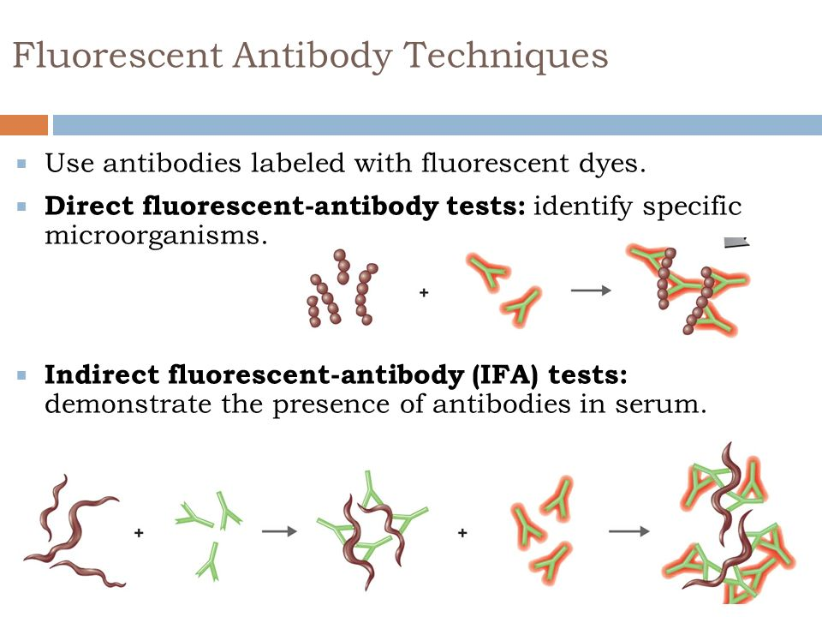

**[Secondary Antibody Detection Probes](https://www.biosyn.com/secondary-antibody-detection-probes.aspx" \o "Secondary Antibody Detection Probes)**

[Conjugation of secondary antibodies, biotin-binding protein, antibody-binding protein with various types of dyes and nanoparticles.](https://www.biosyn.com/secondary-antibody-detection-probes.aspx" \o "Secondary Antibody Detection Probes)

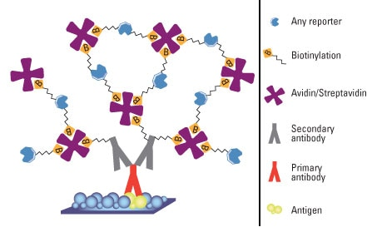

**[Antibody Enzyme Labeling](https://www.biosyn.com/antibody-enzyme-labeling-services.aspx" \o "Antibody Enzyme Labeling)**

[Lable your primary antibody with Horseradish peroxidase (HRP), Alkaline phosphatase (AP) and B-gatactosidase.](https://www.biosyn.com/antibody-enzyme-labeling-services.aspx" \o "Antibody Enzyme Labeling)



1
2- Labeled antibody techniques :
• Several types of immunological tests used labeled antibodies in the test design .
• M...Antibody Liposome Conjugation

We save you time by providing high quality antibody-liposome conjugates for diagnostic and targeted drug delivery. (<https://www.youtube.com/watch?v=cbYAH6JGZpA>)



[Antibody Nanoparticles Labeling](https://www.biosyn.com/nanoparticle-antibody-labeling-services.aspx" \o "Antibody Nanoparticles Labeling)

[Bioconjugation of antibodies or other biomolecules to various types of nanoparticles such as gold, crystal, and Qdot through various functional groups.](https://www.biosyn.com/nanoparticle-antibody-labeling-services.aspx" \o "Antibody Nanoparticles Labeling)

 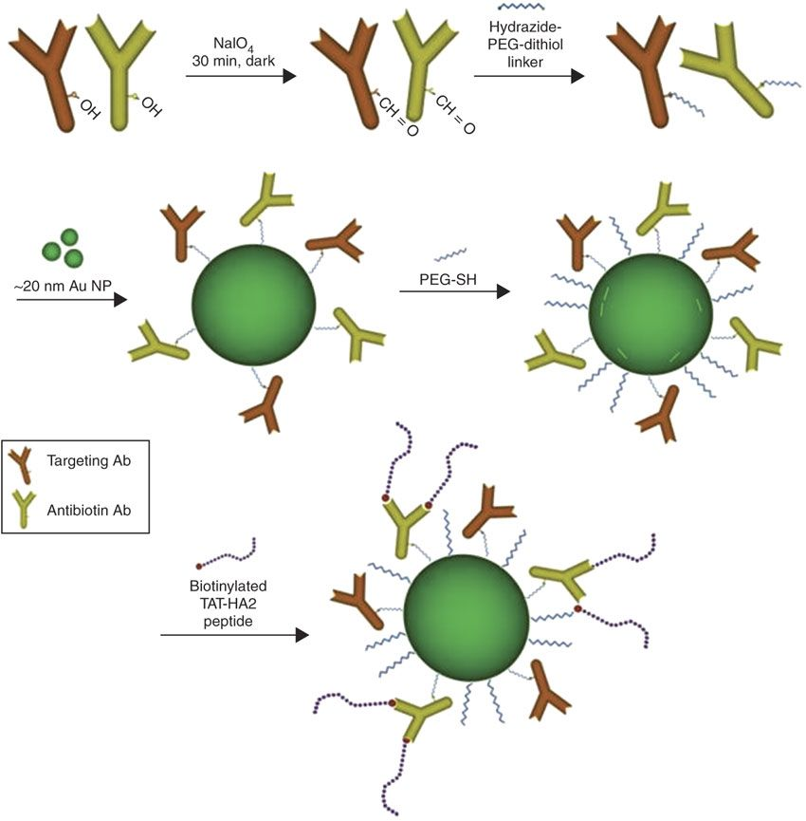

[Antibody Immobilization](https://www.biosyn.com/antibody-immobilization-services.aspx" \o "Antibody Immobilization)

[Immobilizing antibody on supports such as agarose, dextran gels, membranes, beads/plates and resins/beads through various functional groups.](https://www.biosyn.com/antibody-immobilization-services.aspx" \o "Antibody Immobilization)

[](https://www.biosyn.com/antibody-immobilization-services.aspx" \o "Antibody Immobilization)

**[An antibody immobilized onto a plastic surface (such as a well in a microtiter](https://www.biosyn.com/antibody-fragmentation-services.aspx" \o "Antibody Fragmentation)[®](https://www.biosyn.com/antibody-fragmentation-services.aspx" \o "Antibody Fragmentation)[plate) captures the test analyte from the sample, and a different antibody, specific for another part of the analyte molecule, is used as the basis of the signal generation system.](https://www.biosyn.com/antibody-fragmentation-services.aspx" \o "Antibody Fragmentation)**

[Antibody Fragmentation](https://www.biosyn.com/antibody-fragmentation-services.aspx" \o "Antibody Fragmentation)

[Antibody fragmentation services from dialysis, digestion, concentration and purification.](https://www.biosyn.com/antibody-fragmentation-services.aspx" \o "Antibody Fragmentation)

[](https://www.biosyn.com/antibody-fragmentation-services.aspx" \o "Antibody Fragmentation)

[Antibody Oligonucleotide Conjugation](https://www.biosyn.com/antibody-oligonucleotide-conjugation-services.aspx" \o "Antibody Oligonucleotide Conjugation)

[Antibody oligo conjugates for Immuno-PCR or Multiplexed assay development. A suitable tool for highly sensitive protein detection. ](https://www.biosyn.com/antibody-oligonucleotide-conjugation-services.aspx" \o "Antibody Oligonucleotide Conjugation)